Technical Architecture & Stacks

Technical Architecture

|  |  |
| --- | --- |
| Date | 19 September 2022 |
| Team ID | PNT2022TMID43270 |
| Project Name | Signs with smart connectivity for better road safety |
| Maximum Marks | 2 Marks |

**Introduction**

The Internet of Things (IoT) departs from the conceptualization that everyday objects have internet connection and are equipped with sensing, actuation and processing capabilities so that such devices will provide benefits both in terms of new services and in terms of efficiency improvement for existing services and processes [1]. The IoT is considered a large-scale system that allows billions of physical objects to communicate with each other and collect data over the internet [2]. In this regard, the concept of “things”—devices with sensing and computing capabilities that communicate with other devices/things, bringing new functionalities and added value into many application domains—has appeared

**The Benefits Of IoT On The Road**

Using IoT technology, it’s possible to eliminate risks, avoid damage, and reduce costs. Moreover, with smart devices and connected sensors, we can gather and analyze pertinent data. This information will enable authorities to develop sensible strategies that promote optimal safety. Best of all, IoT technology makes it easier to predict the outcome and efficacy of specific measures and precautions.

**Traffic Avoidance**

Traffic control plays a prominent role in keeping roads clear and safe. Without adequate traffic control, inclement weather and road hazards are liable to trigger traffic jams and incidents. With that said, to stave off potentially dangerous situations, cities need to have a handle on traffic issues.

IoT road sensors assist in doing just that. By providing real-time data, IoT sensors breathe clarity and transparency into traffic developments. Most notably, this technology seamlessly integrates into existing systems. Sensors can be added under roads, measuring weather, traffic volume, and accident changes as cars drive by.

**Driving Forward**

IoT is already helping make our roads much safer. But this is just the beginning. The true power of IoT in ensuring safe driving continues to be unleashed as cars move toward becoming fully [autonomous](https://impacx.io/blog/autonomous-cars/) and start interacting with their environment and making decisions on their own.

If you want to learn more about IoT on the Road, you can speak to one of the team members at Davra to explain how IoT technology can benefit your drivers and help you contribute to road safety. Click [here](https://davra.com/contact/) to contact Davra today!

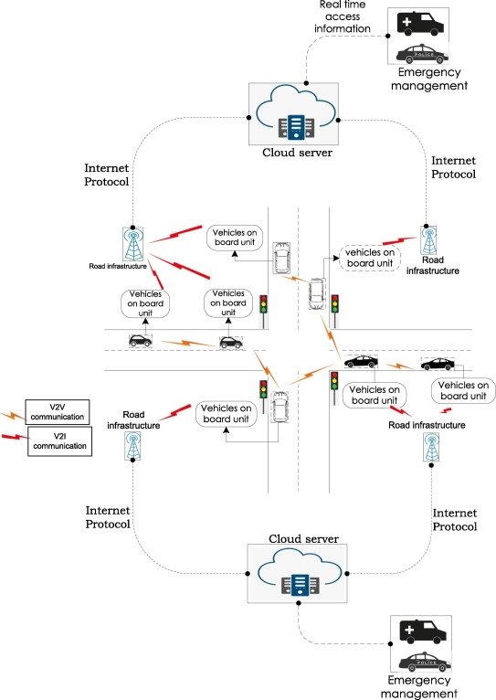

**Use case: autonomous driving**

As connected and automated driving are significantly benefiting from advances in secure, trusted IoT, the AD use case is exploited to demonstrate trustworthiness of developed assets, which are covering major parts of the AD value chain. The intricate technical solutions encompassed by AD are achieving marketable levels of maturity. The core is formed around CPS capable of hosting high-performance computing and connectivity. In contrast to historic addition of control units for each fresh functionality, the current trend bases control strategy on centrali

**Design and architecture**

The concept of life-cycle management is further bolstered by development of components and their integration into an architecture that is designed with effective safety and security in mind. The architecture is an integral component of connectivity mechanisms to protect vehicles, which are becoming increasingly vulnerable to cyberthreats due to the rise of communication access points into vehicles. The concept of Digital Twins is used as a security and safety enhancing tool for communication and control components of the proposed architecture. Digital twins of complex systems aid addressing of potential attacks through virtualisation, which if applied at both, early development stages and at runtime operation, should help tackle risks early in the life-cycle of the control CPS. The run-time risks are further mitigated using novel dependability design methods. These are crucial for AD that is pushing towards integration of datadriven controllers with self-adaptable properties during own operating lifetime. Title Suppressed Due to Excessive Length 5 As such, they are prone to exhibiting behaviour that is not possible to predict at design stages. Such behaviour may result from vehicle detecting an unfamiliar environment. In such occasions, it is the secure localization that maps vehicles surroundings and provides information needed for decision making

